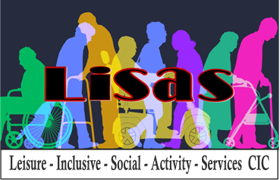

**Volunteer Application form**

|  |
| --- |
| **Thank you for your interest in volunteering with LISAS CIC. If you are unclear about any sections of this form, please let us know. We would be happy to support you in completing the form if that would help.**  **We are committed to equal opportunities. Applications are invited from anyone over the age of 18 years old** |
| **Please tell us the volunteer role you are interested in, i.e., which social groups Tuesday morning (over 50s group), Tuesday afternoon (dementia group), Wednesday afternoon (over 50s group) or Thursday afternoon (dementia group), outings or all** |
| **Your name:** |
| **Your address:** |
| **Your preferred contact telephone number:** |
| **Your email address:** |
| **Date of birth:** |
| **Your availability:**  **Do you have any preferred days of the week that you would like to volunteer? Are you available every week, once a month...?** |
| **About you (previous Volunteering roles, qualifications, experience of working with vulnerable people etc)** |
| **Details of someone who can give you a reference (this should be a person who is not a family member and has known you for over a year)**  **Name: Relationship to you:**  **Contact number: Email address:** |